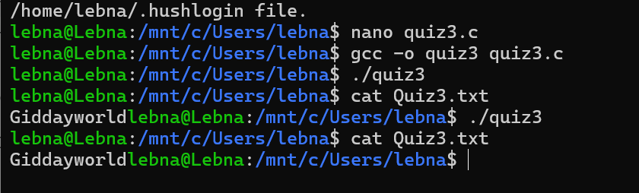

First we opens the file Quiz3.txt three times:
- fd1 opens it (create/truncate mode).
- fd2 duplicates fd1 (shares same file offset).
- fd3 opens it again separately (independent offset).
Second we write
- "Hello," (6 bytes) using fd1.
- Writes "world" (5 bytes) using fd2 right after "Hello,".
- Moves file offset back to start using fd2.
- "HELLO," (6 bytes) using fd1, overwriting "Hello,".
- "Gidday" (6 bytes) using fd3, which overwrites from the start independently.
The output of the file is " Gidday " as it overwrites the first 6 bytes (from fd3), and "world" is after "Gidday" (from prev wrting).

